**Name: Sehrish Khan**

**Roll No.: Bsf2106394**

**Section: A Sem-III**

**Assignment: Principles of Macroeconomics**

**Submitted to: Mam Huma**

**Topic: Unemployment**

**Unemployment and Types of Unemployment**

**Labor force**

The labor force, or currently active population, comprises all persons who fulfil the requirements for inclusion among the employed (civilian employment plus the armed f8orces) or the unemployed.

In other words,

**Labor Force = Employed +Unemployed**

**Labor Participation Rate**

Labor force participation rate is the rate of all people who supply labor to produce goods and services during a specified period.

It can be calculated from the following formula**.**

Participation Rate = **(Labor Force ÷ Civilian Noninstitutional Population) x 100**.

**Unemployment**

The term unemployment refers to a situation where a person actively searches for employment but is unable to find work. Unemployment is a key measure of the health of the economy. The most frequently used measure of unemployment is the unemployment rate

**Unemployment Rate**

The unemployment rate is the percentage of people in the labor force who are unemployed. Consequently, measuring the unemployment rate requires identifying who is in the labor force. The labor force includes people who are either employed or unemployed.

The unemployment rate formula is.

**the number of unemployed people in the country, divided by the total number of workers available in the civilian labor force**.

**Types of Unemployment**

There are six types of unemployment.

**Structural Unemployment**

Structural unemployment is long-lasting unemployment that comes about due to shifts in an economy. This type of unemployment happens because though jobs are available, there's a mismatch between what companies need and what available workers offer.

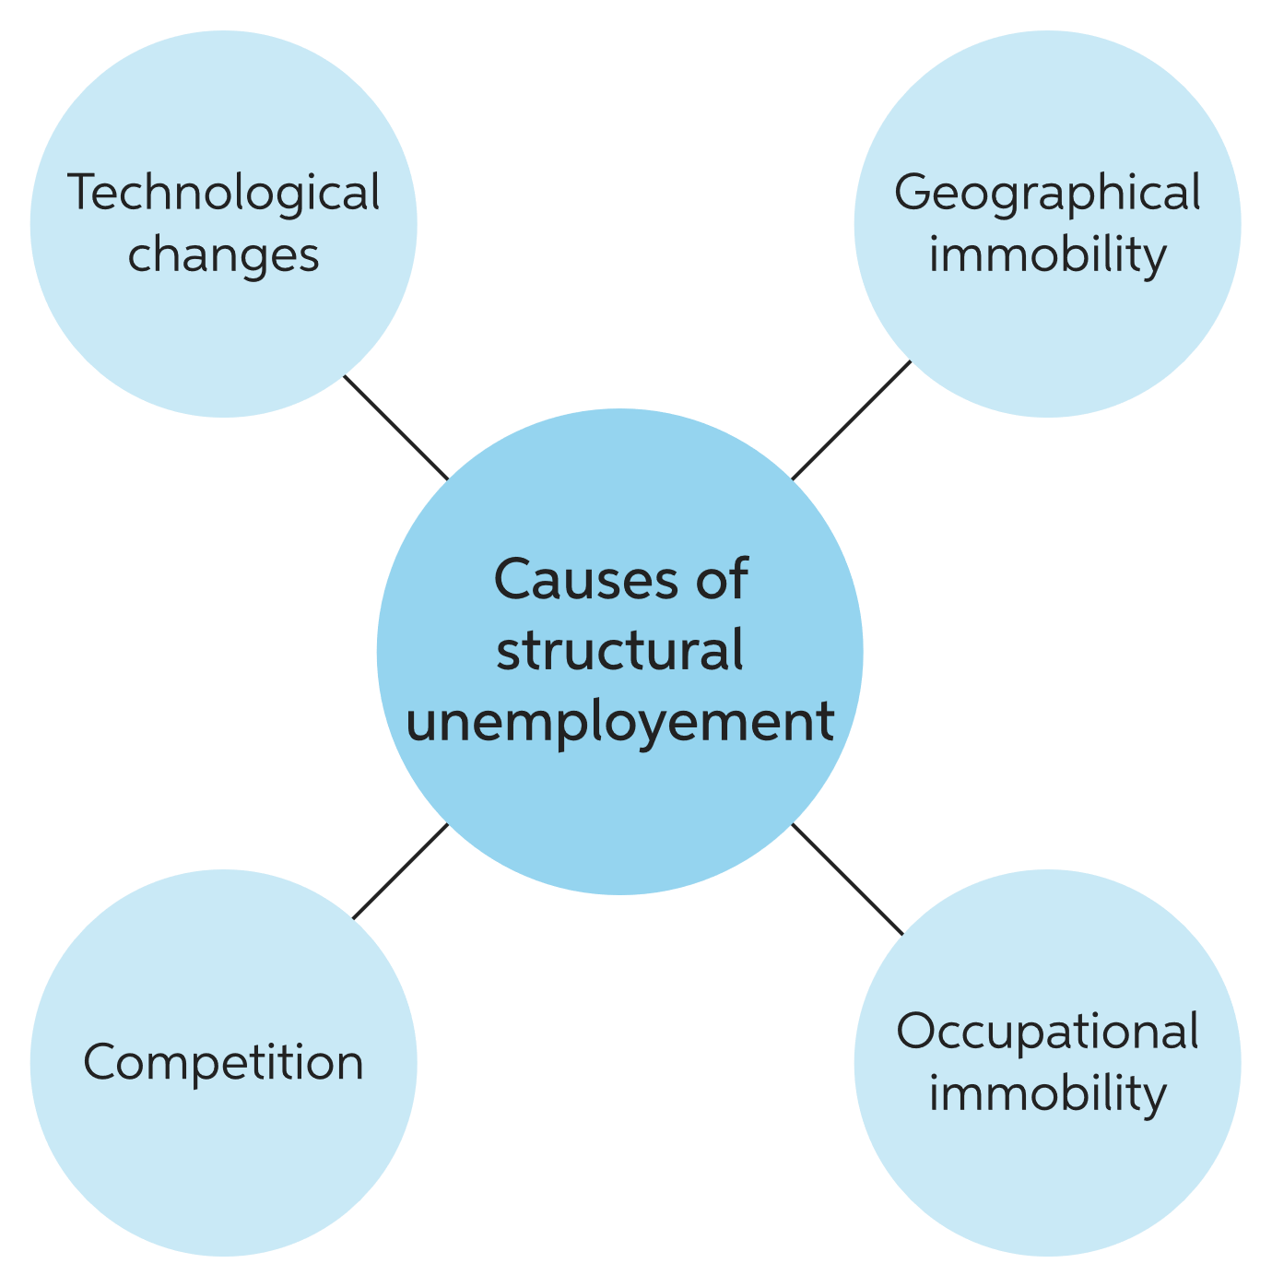

**Example:**

For example, employees who produce a specialty clothing product that suddenly is no longer a trend might lose their position producing this specific product, causing structural unemployment.

**Cyclical Unemployment**

Cyclical unemployment is the component of overall unemployment that results directly from cycles of economic upturn and downturn. Unemployment typically rises during recessions and declines during economic expansions.

**Example**:

An example of cyclical unemployment is when construction workers were laid off during the Great Recession following the financial crisis of 2008. With the housing market struggling, construction of new homes fell dramatically, leading to a rise in cyclical unemployment for construction workers.

**Seasonal Unemployment**

It refers to a situation where several persons are not able to find a job in a particular season. It occurs in the case of agriculture, ice-cream factories, woolen factories, etc. It occurs when people are unemployed at times of the year when demand for labor is lower than usual. It refers to a temporary window of time where the number of available employment opportunities decreases.

**Example:**

This typically occurs when a specific time of year ends or a new season begins, such as for a holiday or due to weather changes. For example, someone who works at a resort during the summer might experience unemployment once the fall arrives and summer facilities must close.

**Frictional Unemployment**

Frictional unemployment is a type of short-term unemployment. Frictional unemployment happens when a person is voluntarily job searching or searching for a new career. Frictional unemployment isn't necessarily a bad thing.

It is a form of unemployment that is completely dependent upon the situations of a person.

**Example:**

A person is frictionally unemployed if they voluntarily leave or are fired from their job. New entrants into the workforce who are searching for their first job would also count as being frictionally unemployed.

**Disguised Unemployment:**

Disguised unemployment is often referred to as underemployment, hidden unemployment, or partial unemployment. Disguised unemployed refers to workers who are left without work, are working in a redundant manner, or are not being utilized to their full potential.

**Example:**

One example would be workers in the agricultural sector. Specifically, there are certain weeks or months a year, typically during winter, in which there is little activity. In these months, workers are not plying their craft and skills to their full potential.

**Natural rate of Unemployment**

The natural rate of unemployment is the unemployment that happens when the economy's production is at the long run level. It is the average rate of unemployment around which the economy fluctuates. The natural rate of unemployment is mainly determined by the economy's productive capacity and its institutions. It is the rate of unemployment arising from all sources except fluctuations in aggregate demand. Estimates of potential GDP are based on the long-term natural rate.

**Example**

One of the examples of the natural rate of unemployment is recent graduates who haven't secured employment. The time between graduation and finding a job is classified as frictional unemployment, which also constitutes part of the natural unemployment rate.